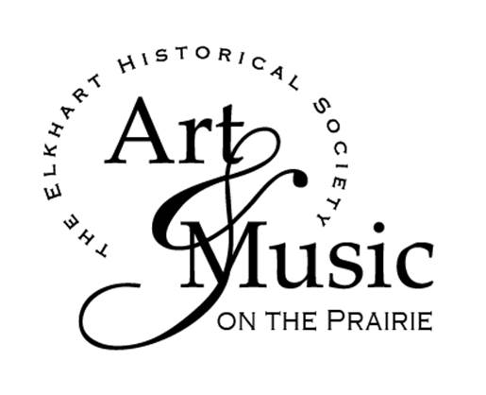

Name__________________________Address:_____________________________

Phone #______________ cell # ______________ Email please print _______________________

Individual $15_________ Couple $25__________ Student with I.D. $10______

At Check in Price (Sep 2nd) $20 Individual/ $35 Couples____________________________

**Please call 217-947-2238 for advance reservations by August 26.2016- -** Once you are confirmed, download the interactive form from the Elkhart Historical Society website [www.elkharthistoricalsociety.org](http://www.elkharthistoricalsociety.org) and mail it in with your **check, payable to The Elkhart Historical Society, P.O. 255, Elkhart, IL 62634.**

Reservations forms are also available at Horsefeathers and the Country Bumpkin, where you also may leave your completed form with your payment. **You may come without reservations and pay at the check-in table under the Teal Colored Awning the night of the event for $5 additional per person.**

You are welcome to bring a favorite bottle of wine or beer which will be held for you at the Wild Hare Café.

**On Friday- September 2 at 5 P.M.- Please check in under the Teal Colored Awning upon arrival for your official “Stamp” and then let your evening begin!! Begin your walk between the three unique venues- -enjoy music, refreshments, hear artists speak about their work and take home a new piece of art!**

Parking is available on the street on in the village parking lot in the next block.